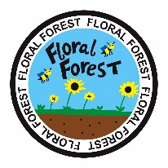

PRIVACY NOTICE
Please be aware that photography/filming is taking place here today.
These photos/videos may be used for promotional purposes.
If you would rather not appear in the photograph/film, you can opt out.
Please speak to the person who is taking the photographs/film if you do not wish to be photographed/filmed.

